Infosys Springboard Virtual Internship 6.0 Completion Report
Batch Number: 6&7
Start date:10 Nov 2025
Name: Arjav Jain
Internship Duration: 8 Weeks

1. Project Title: AI-Powered Application for Early Detection of Heart Disease Risk

2. Project Objective
The primary objective of the project was to develop Cardio Vision AI, a Clinical Decision Support System (CDSS) that leverages Artificial Intelligence and Computer Vision to predict heart disease risk early and accurately.
Key Goals:
- Predict heart disease likelihood with over 85% accuracy using patient vitals (age, blood pressure, cholesterol, etc.).
- Automate digitization of physical/digital medical lab reports using Optical Character Recognition (OCR).
- Provide a secure, role-based web dashboard for doctors and patients to upload reports, view predictions, track historical health trends, and generate PDF reports.
This project addresses the global burden of heart disease (leading cause of 17.9 million deaths annually) by reducing diagnostic delays, minimizing manual errors, and enabling preventive care in resource-limited settings.

3. Project description in detail
Cardio Vision AI is a full-stack web application that automates heart disease risk assessment.
Approach: Users upload images/PDFs of lab reports. The system uses Tesseract OCR with custom regex patterns to extract parameters. Extracted data undergoes feature engineering (e.g., Atherosclerosis Score = (BP × Cholesterol)/100), then fed into an ensemble ML model for prediction. Results include risk level, confidence probability, and recommendations. Data is stored for trend visualization, and PDF reports are generated.
Technology Used:
- Backend: Python, Flask
- ML: Scikit-Learn (Ensemble: Random Forest + Gradient Boosting with Soft Voting)
- OCR: PyTesseract, OpenCV, Regex
- Frontend: Bootstrap 5, Chart.js
- Database: SQLite
- Other: Joblib, ReportLab for PDFs
Impact in Real-World Implementation:
- Reduces diagnosis time from minutes to seconds.
- Minimizes transcription errors in clinics.
- Enables long-term monitoring for "silent" risks.
- Cost-effective (open-source) for deployment in small hospitals.

4. Timeline Overview
Week | Activities Planned | Activities Completed
Week 1 | Project understanding, dataset exploration, literature review | Analyzed UCI Heart Disease dataset, reviewed OCR and ML techniques
Week 2 | Data preprocessing, initial model training | Implemented KNN Imputer, trained base models (accuracy ~89%)
Week 3 | OCR module development | Built robust extraction logic with regex for noisy reports
Week 4 | Flask backend, authentication | Set up routes, user login/register, database schema
Week 5 | Frontend integration, prediction endpoint | Responsive UI with upload and real-time prediction
Week 6 | History tracking, charts, PDF generation | Added database saving, Chart.js trends, report download
Week 7 | Testing, evaluation, refinements | Unit/integration tests, achieved 86.23% accuracy
Week 8 | Documentation, final demo preparation | Compiled report, screenshots, presentation

5a. Key Milestones
Milestone | Description | Date Achieved
Project Kickoff | Project selection and planning | 10 Nov 2024
Prototype/First Draft | OCR + basic prediction functional | 01 Dec 2024
Mid-Term Review | Full backend + frontend integration | 25 Nov 2024
Final Submission | Complete features + testing | 04 Dec 2024
Presentation | Demo and report finalization | 05 Dec 2024

5b. Project execution details
The project followed an iterative approach aligned with MVC architecture:
- Model Layer: Trained ensemble ML model on UCI dataset, handled missing values with KNN Imputer.
- View Layer: Built responsive templates with Bootstrap and Chart.js.
- Controller Layer: Flask handled routing, OCR processing, prediction, and database operations. Execution involved weekly milestones, code versioning, and progressive integration for end-to-end functionality.

6. Snapshots / Screenshots
Dashboard UI with heart disease risk alerts, AI-generated PDF medical reports, and terminal output showing accuracy metrics are included.

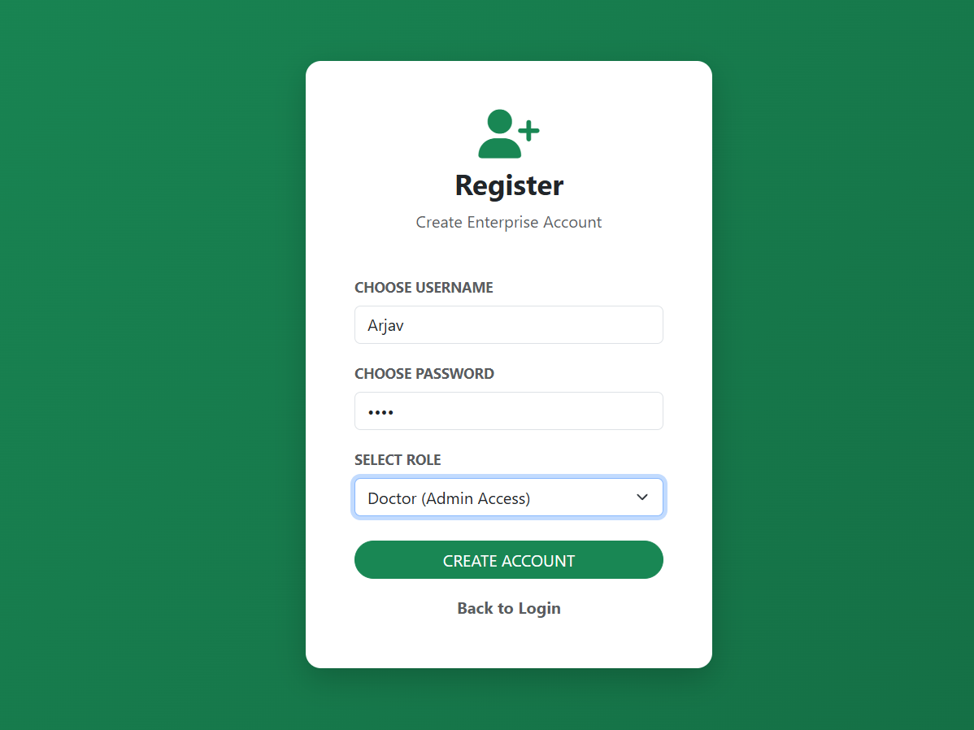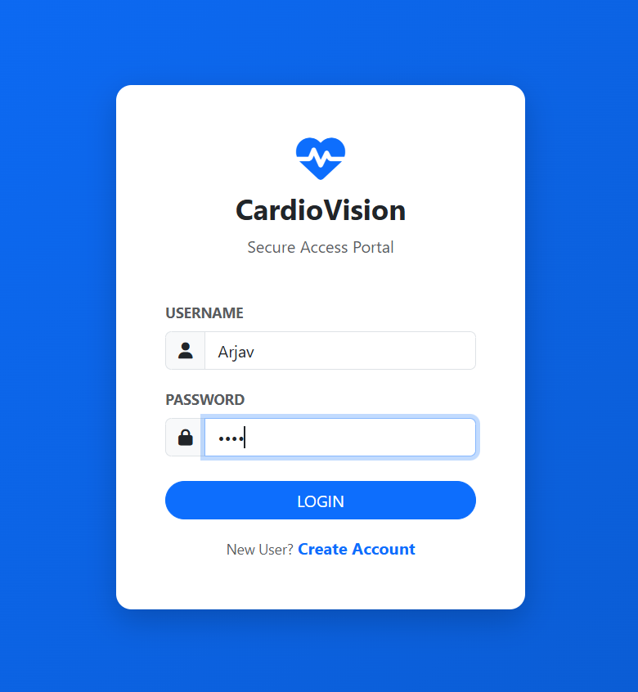
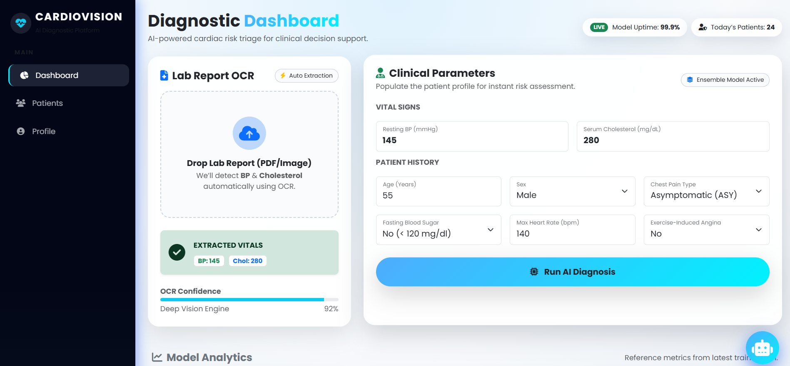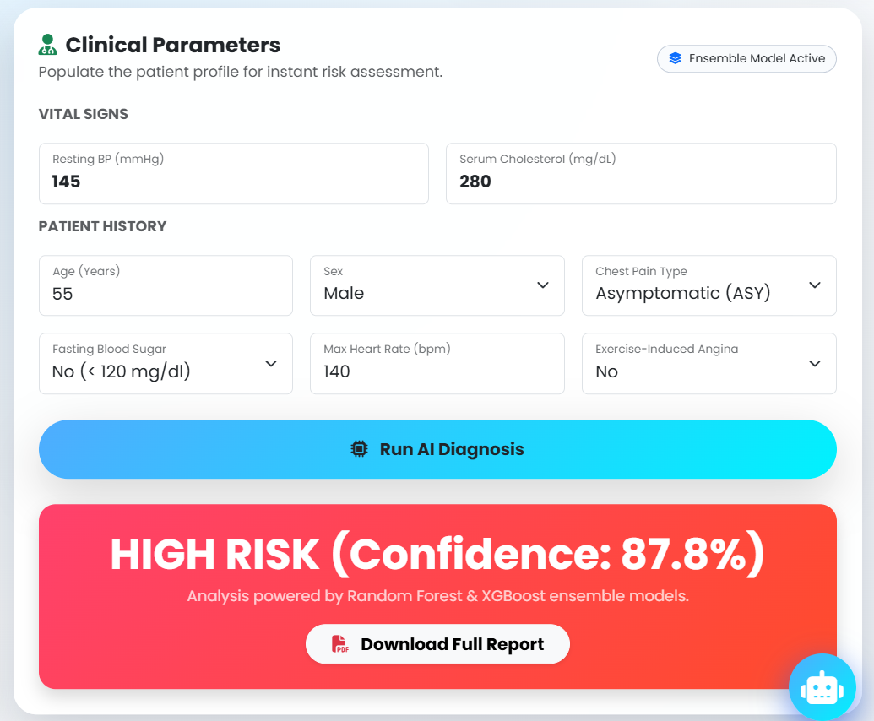
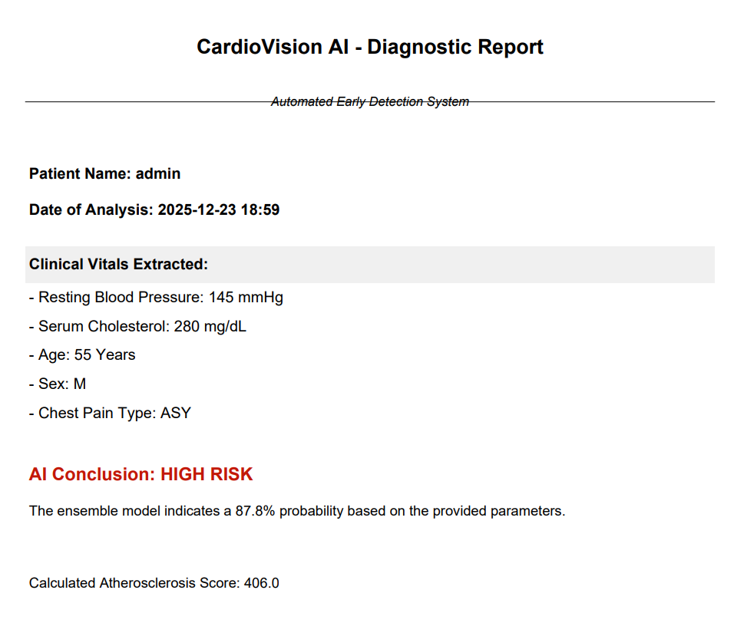

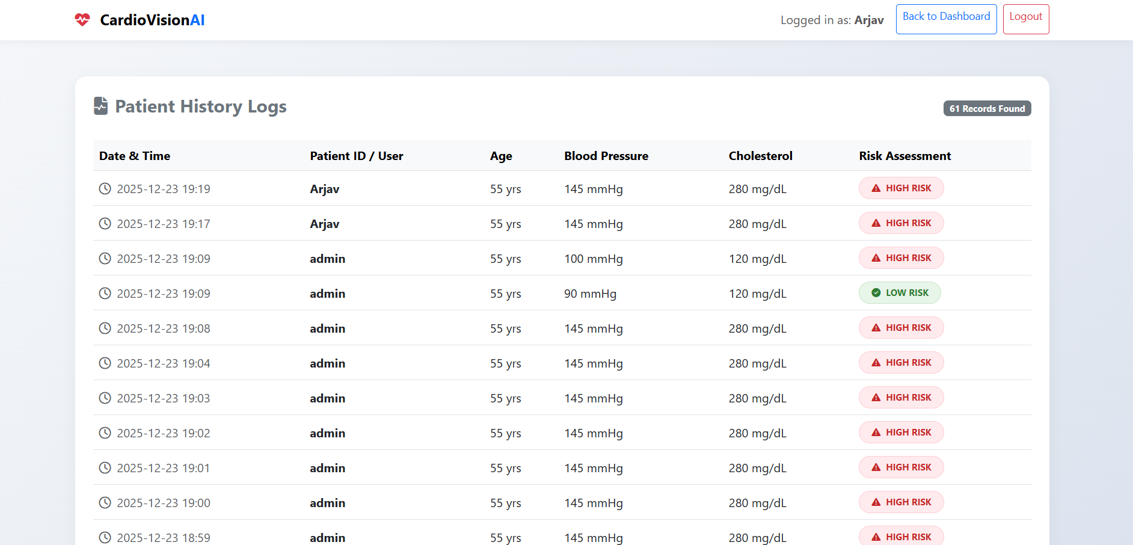
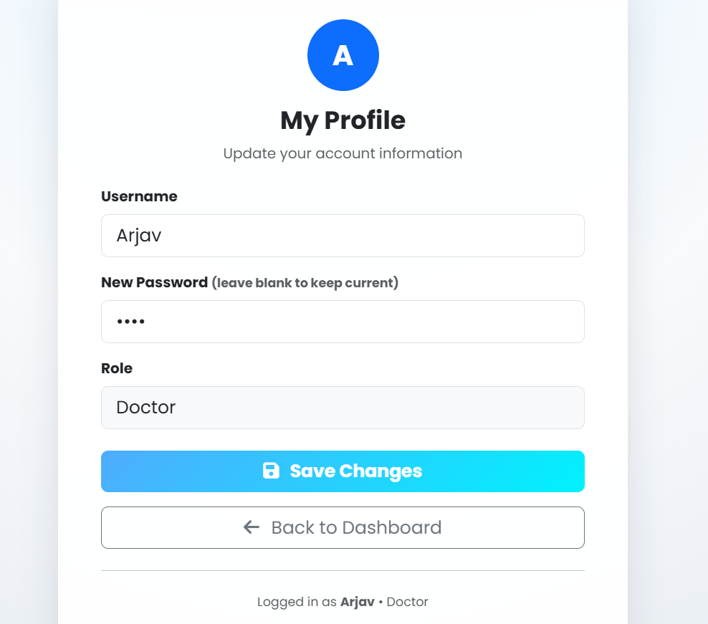
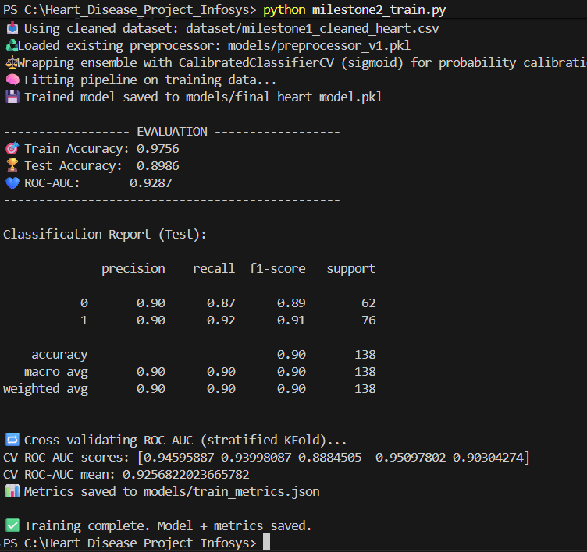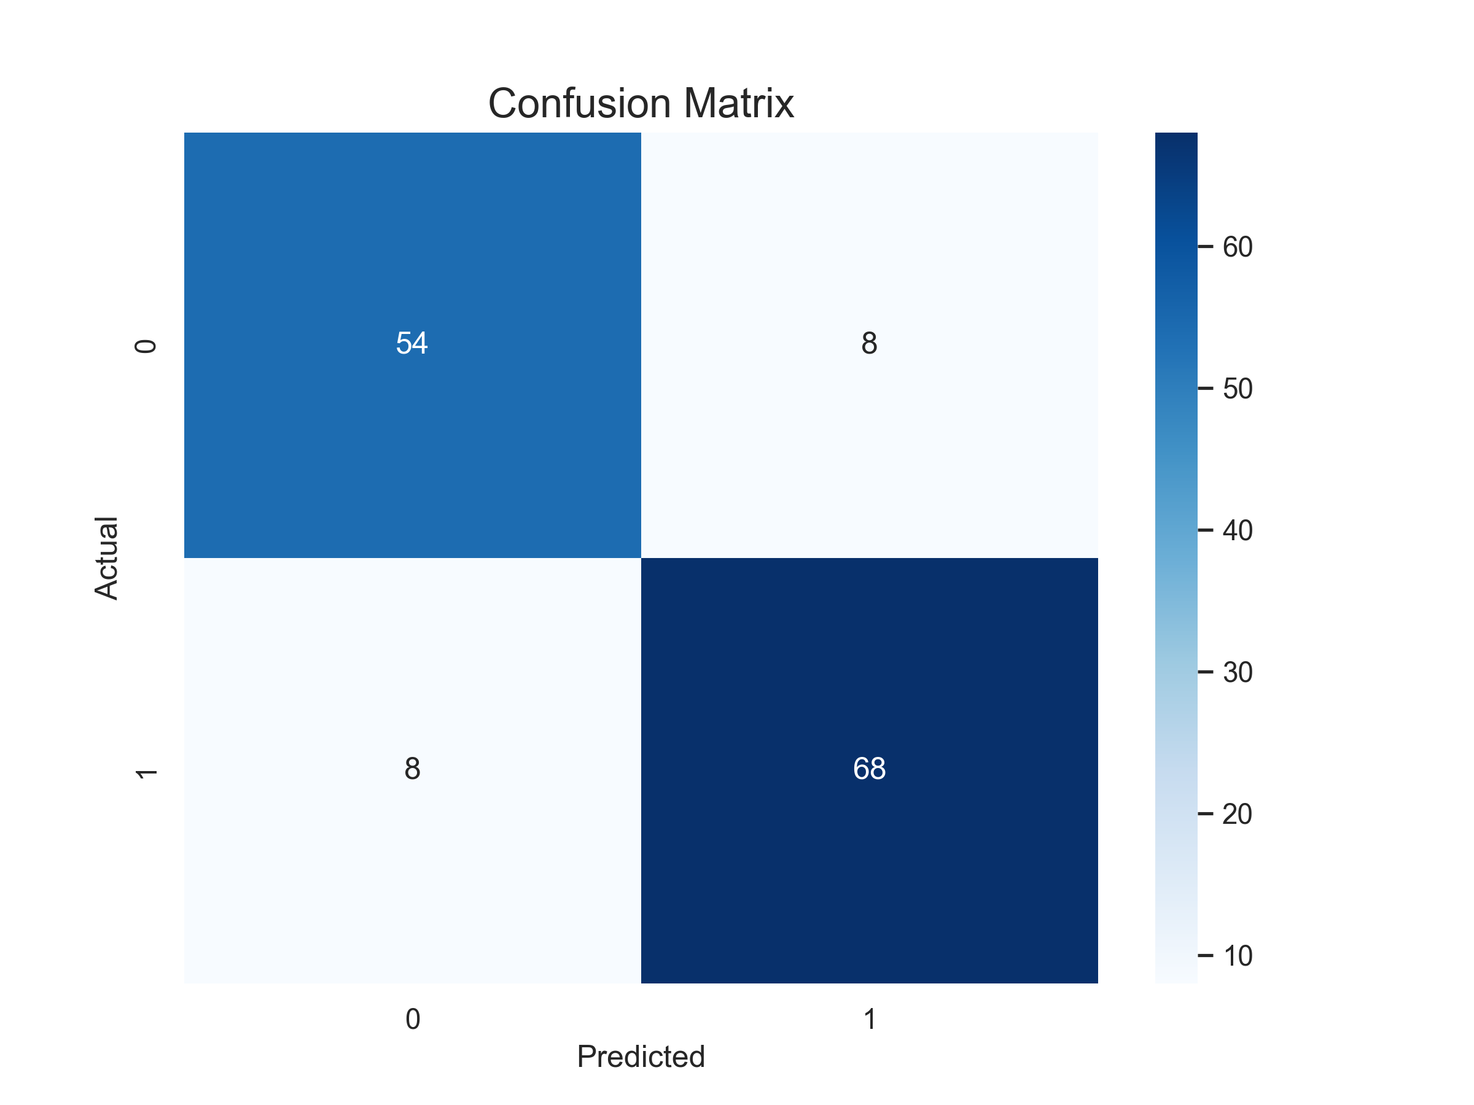
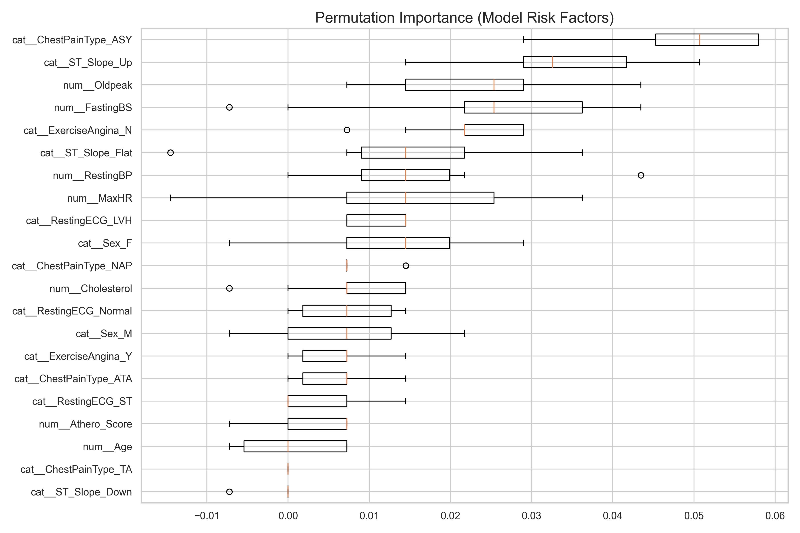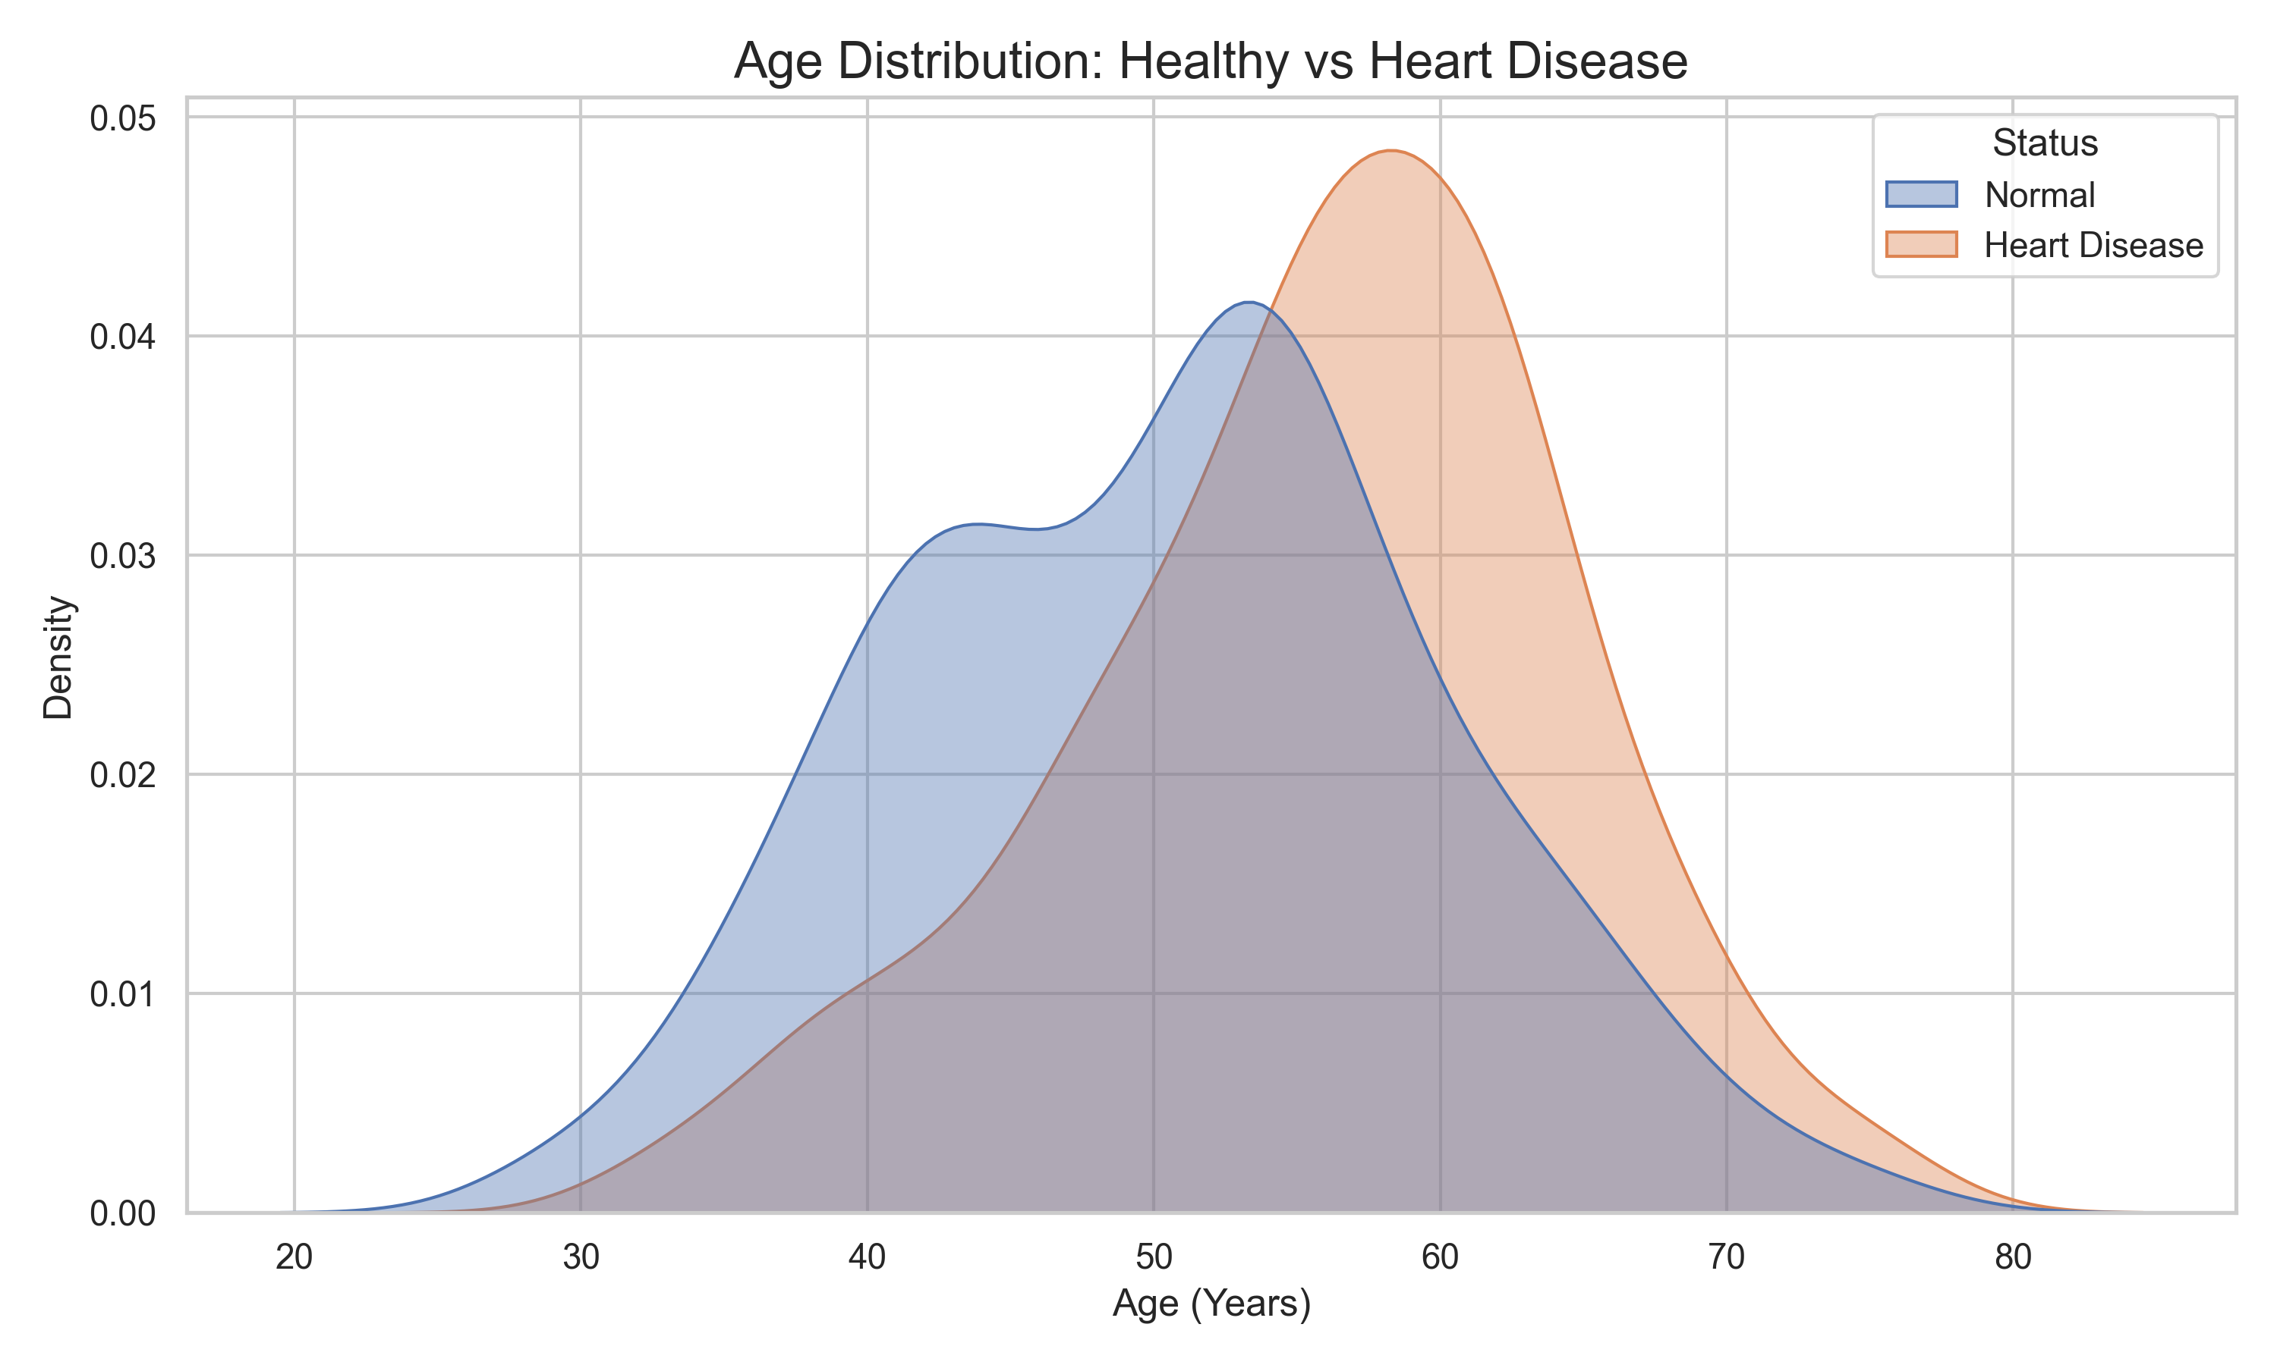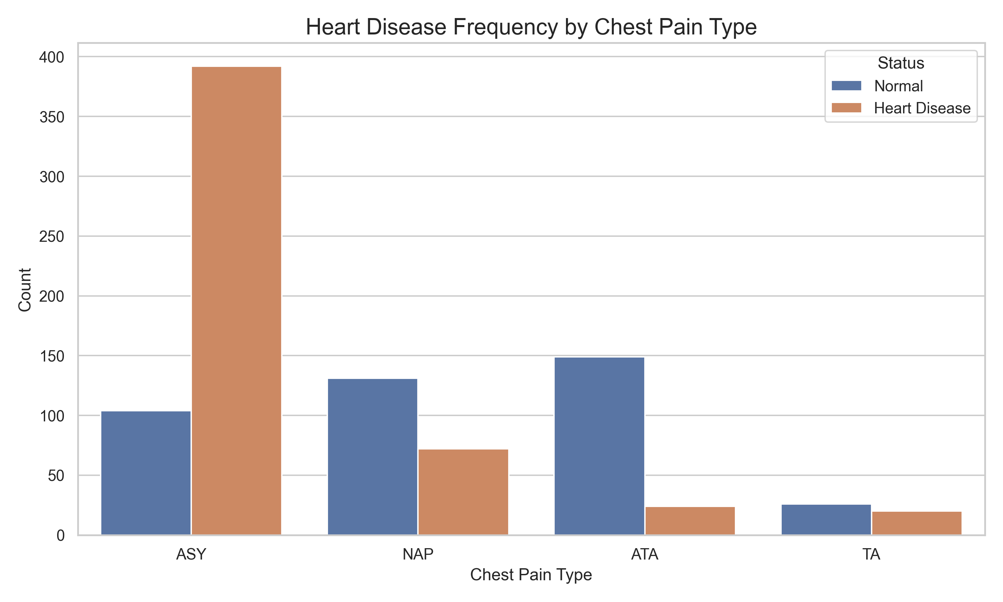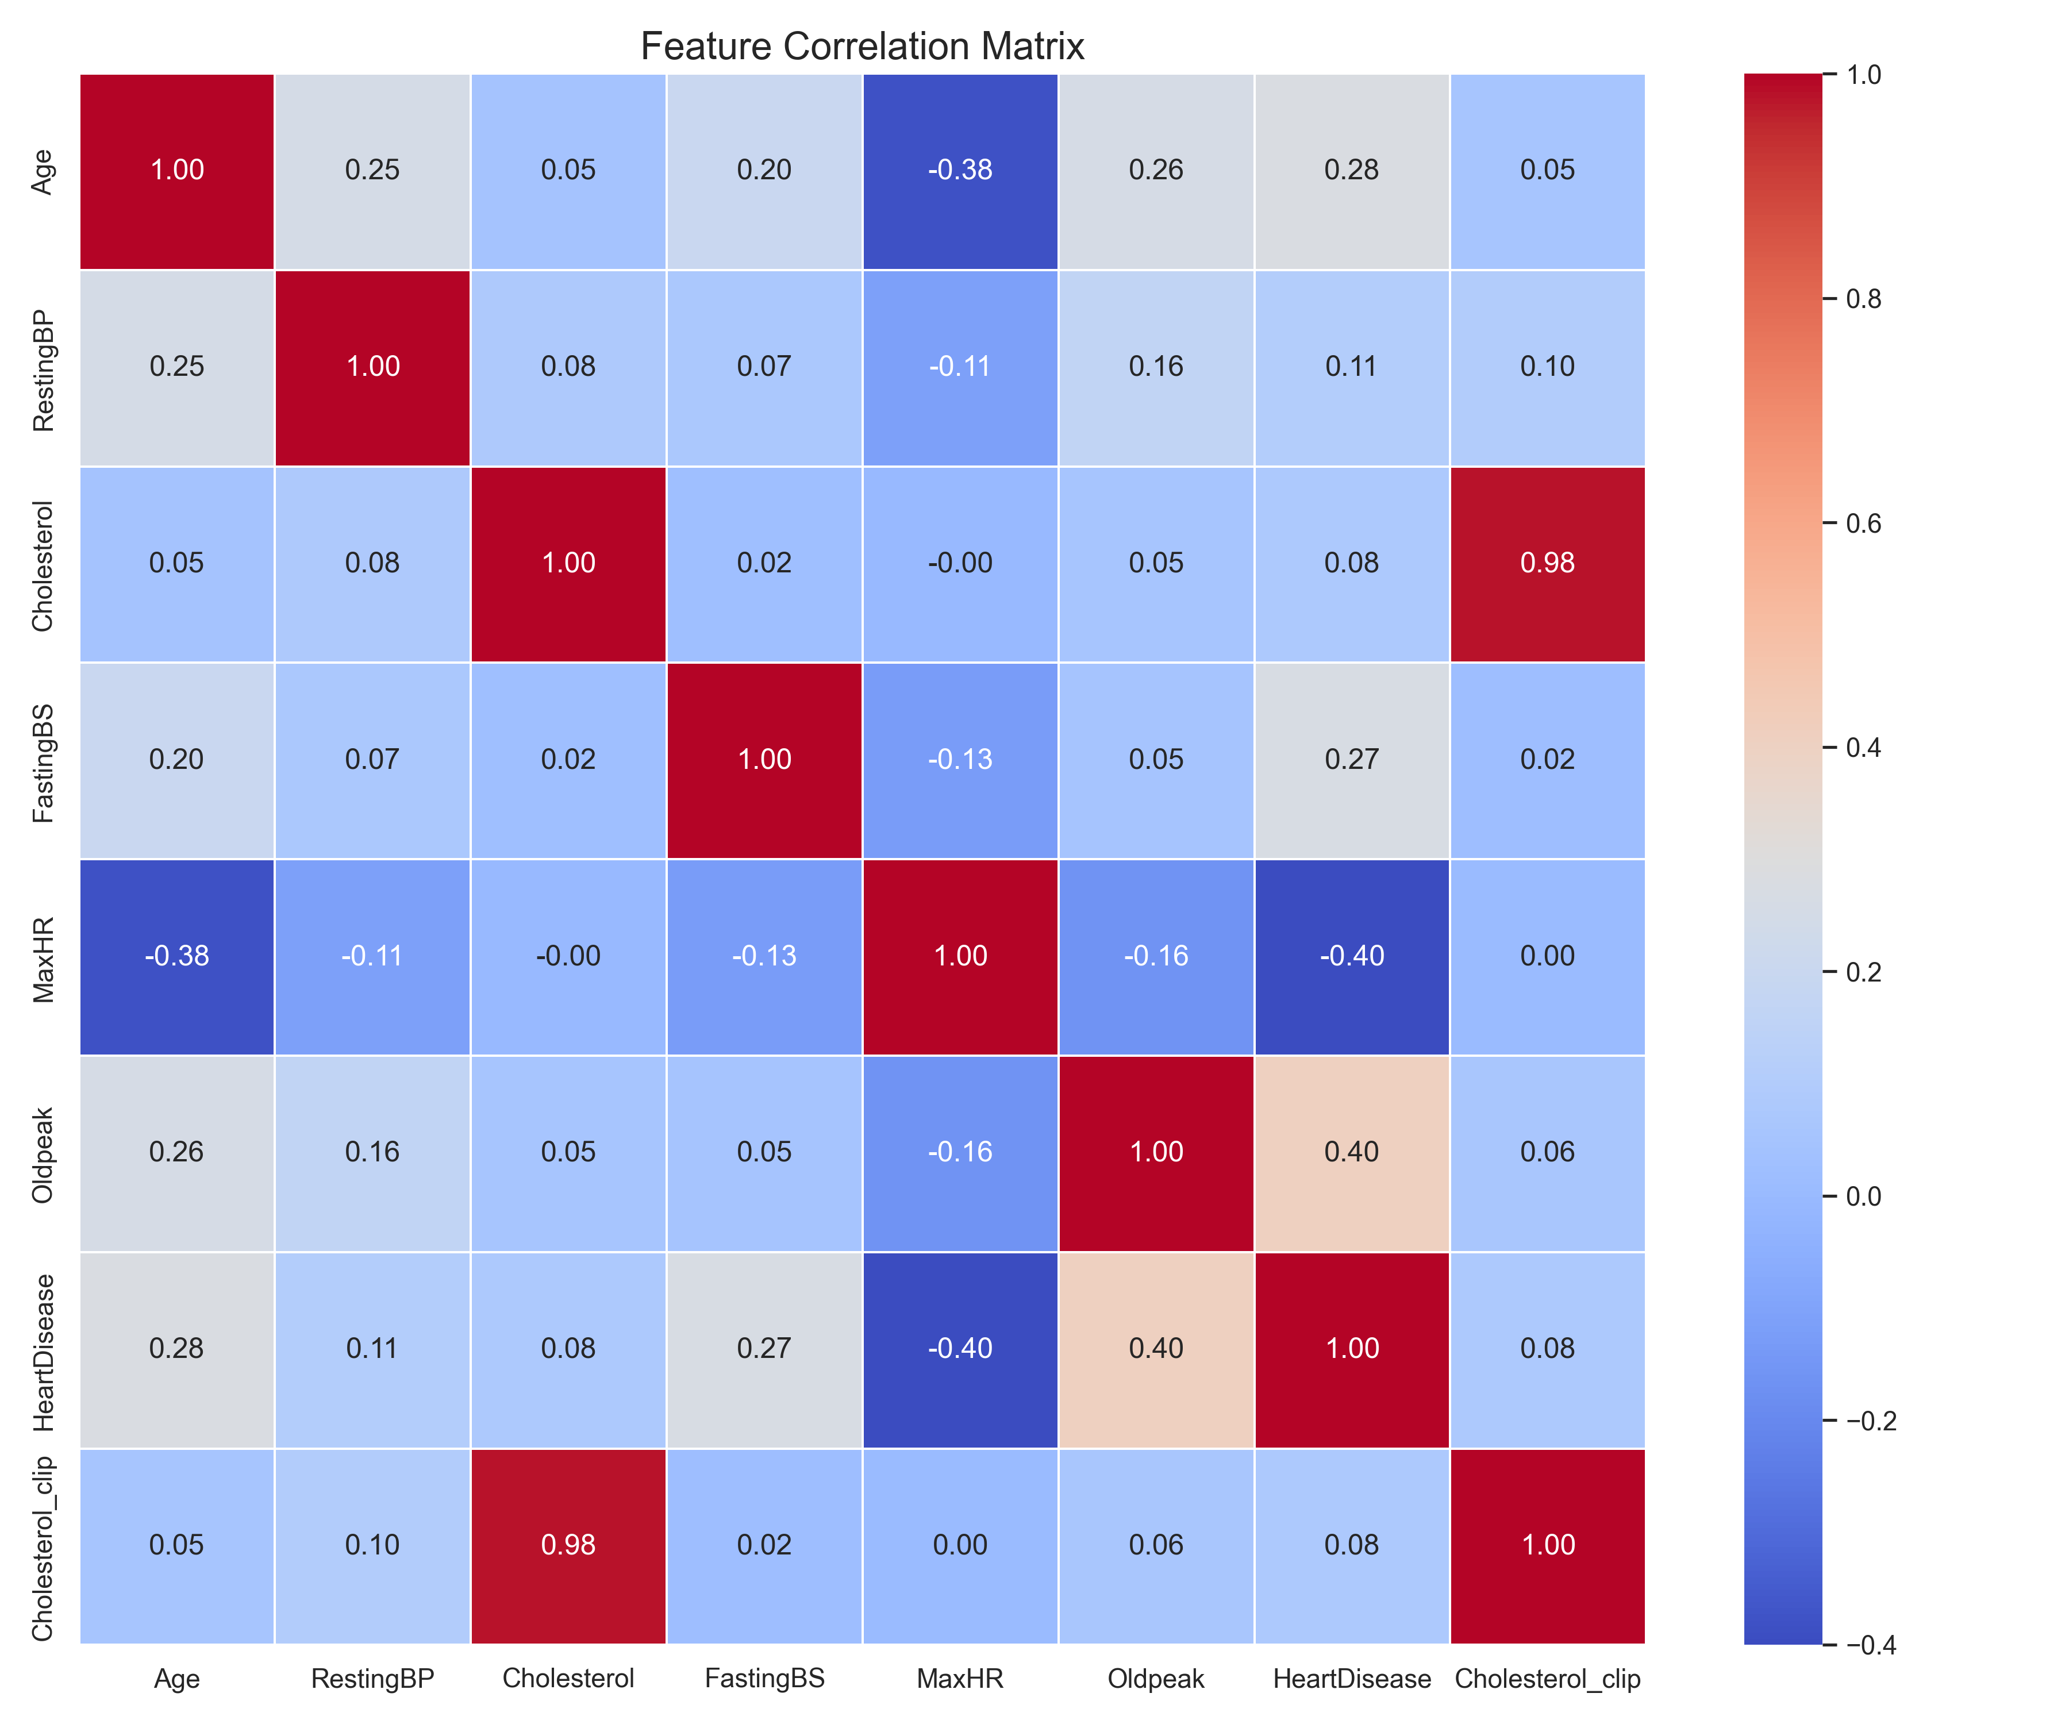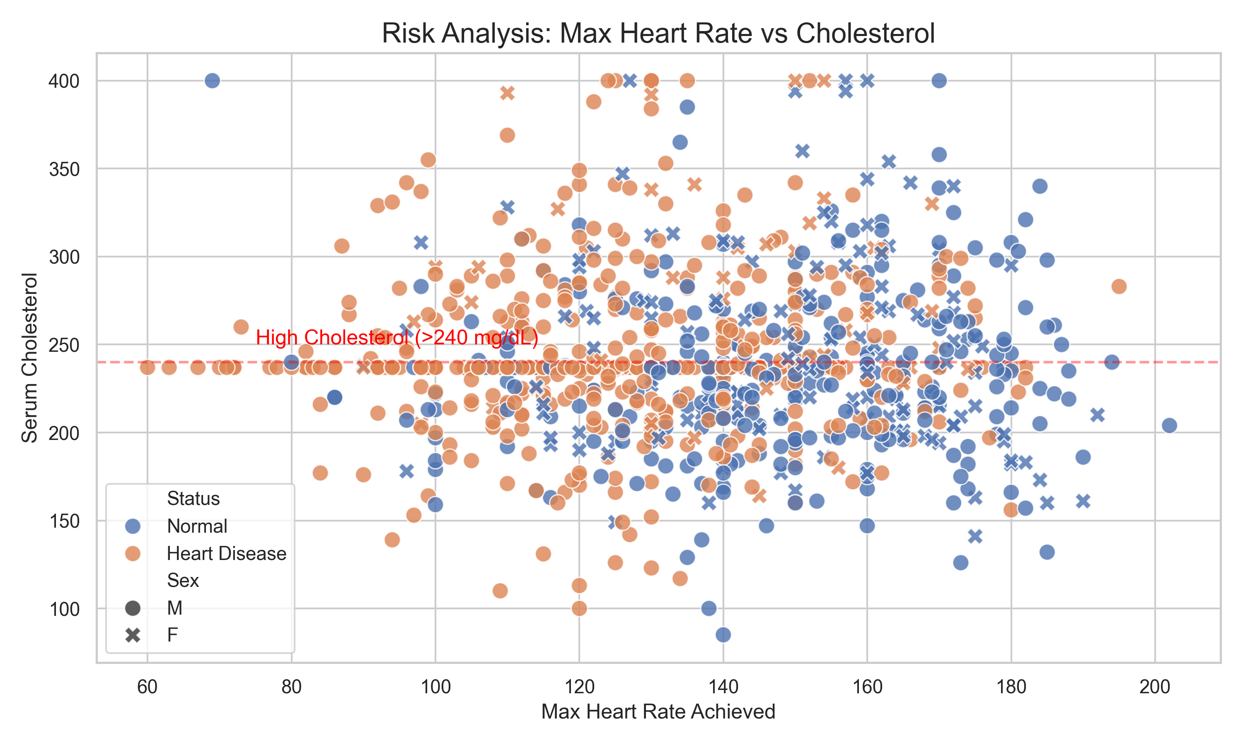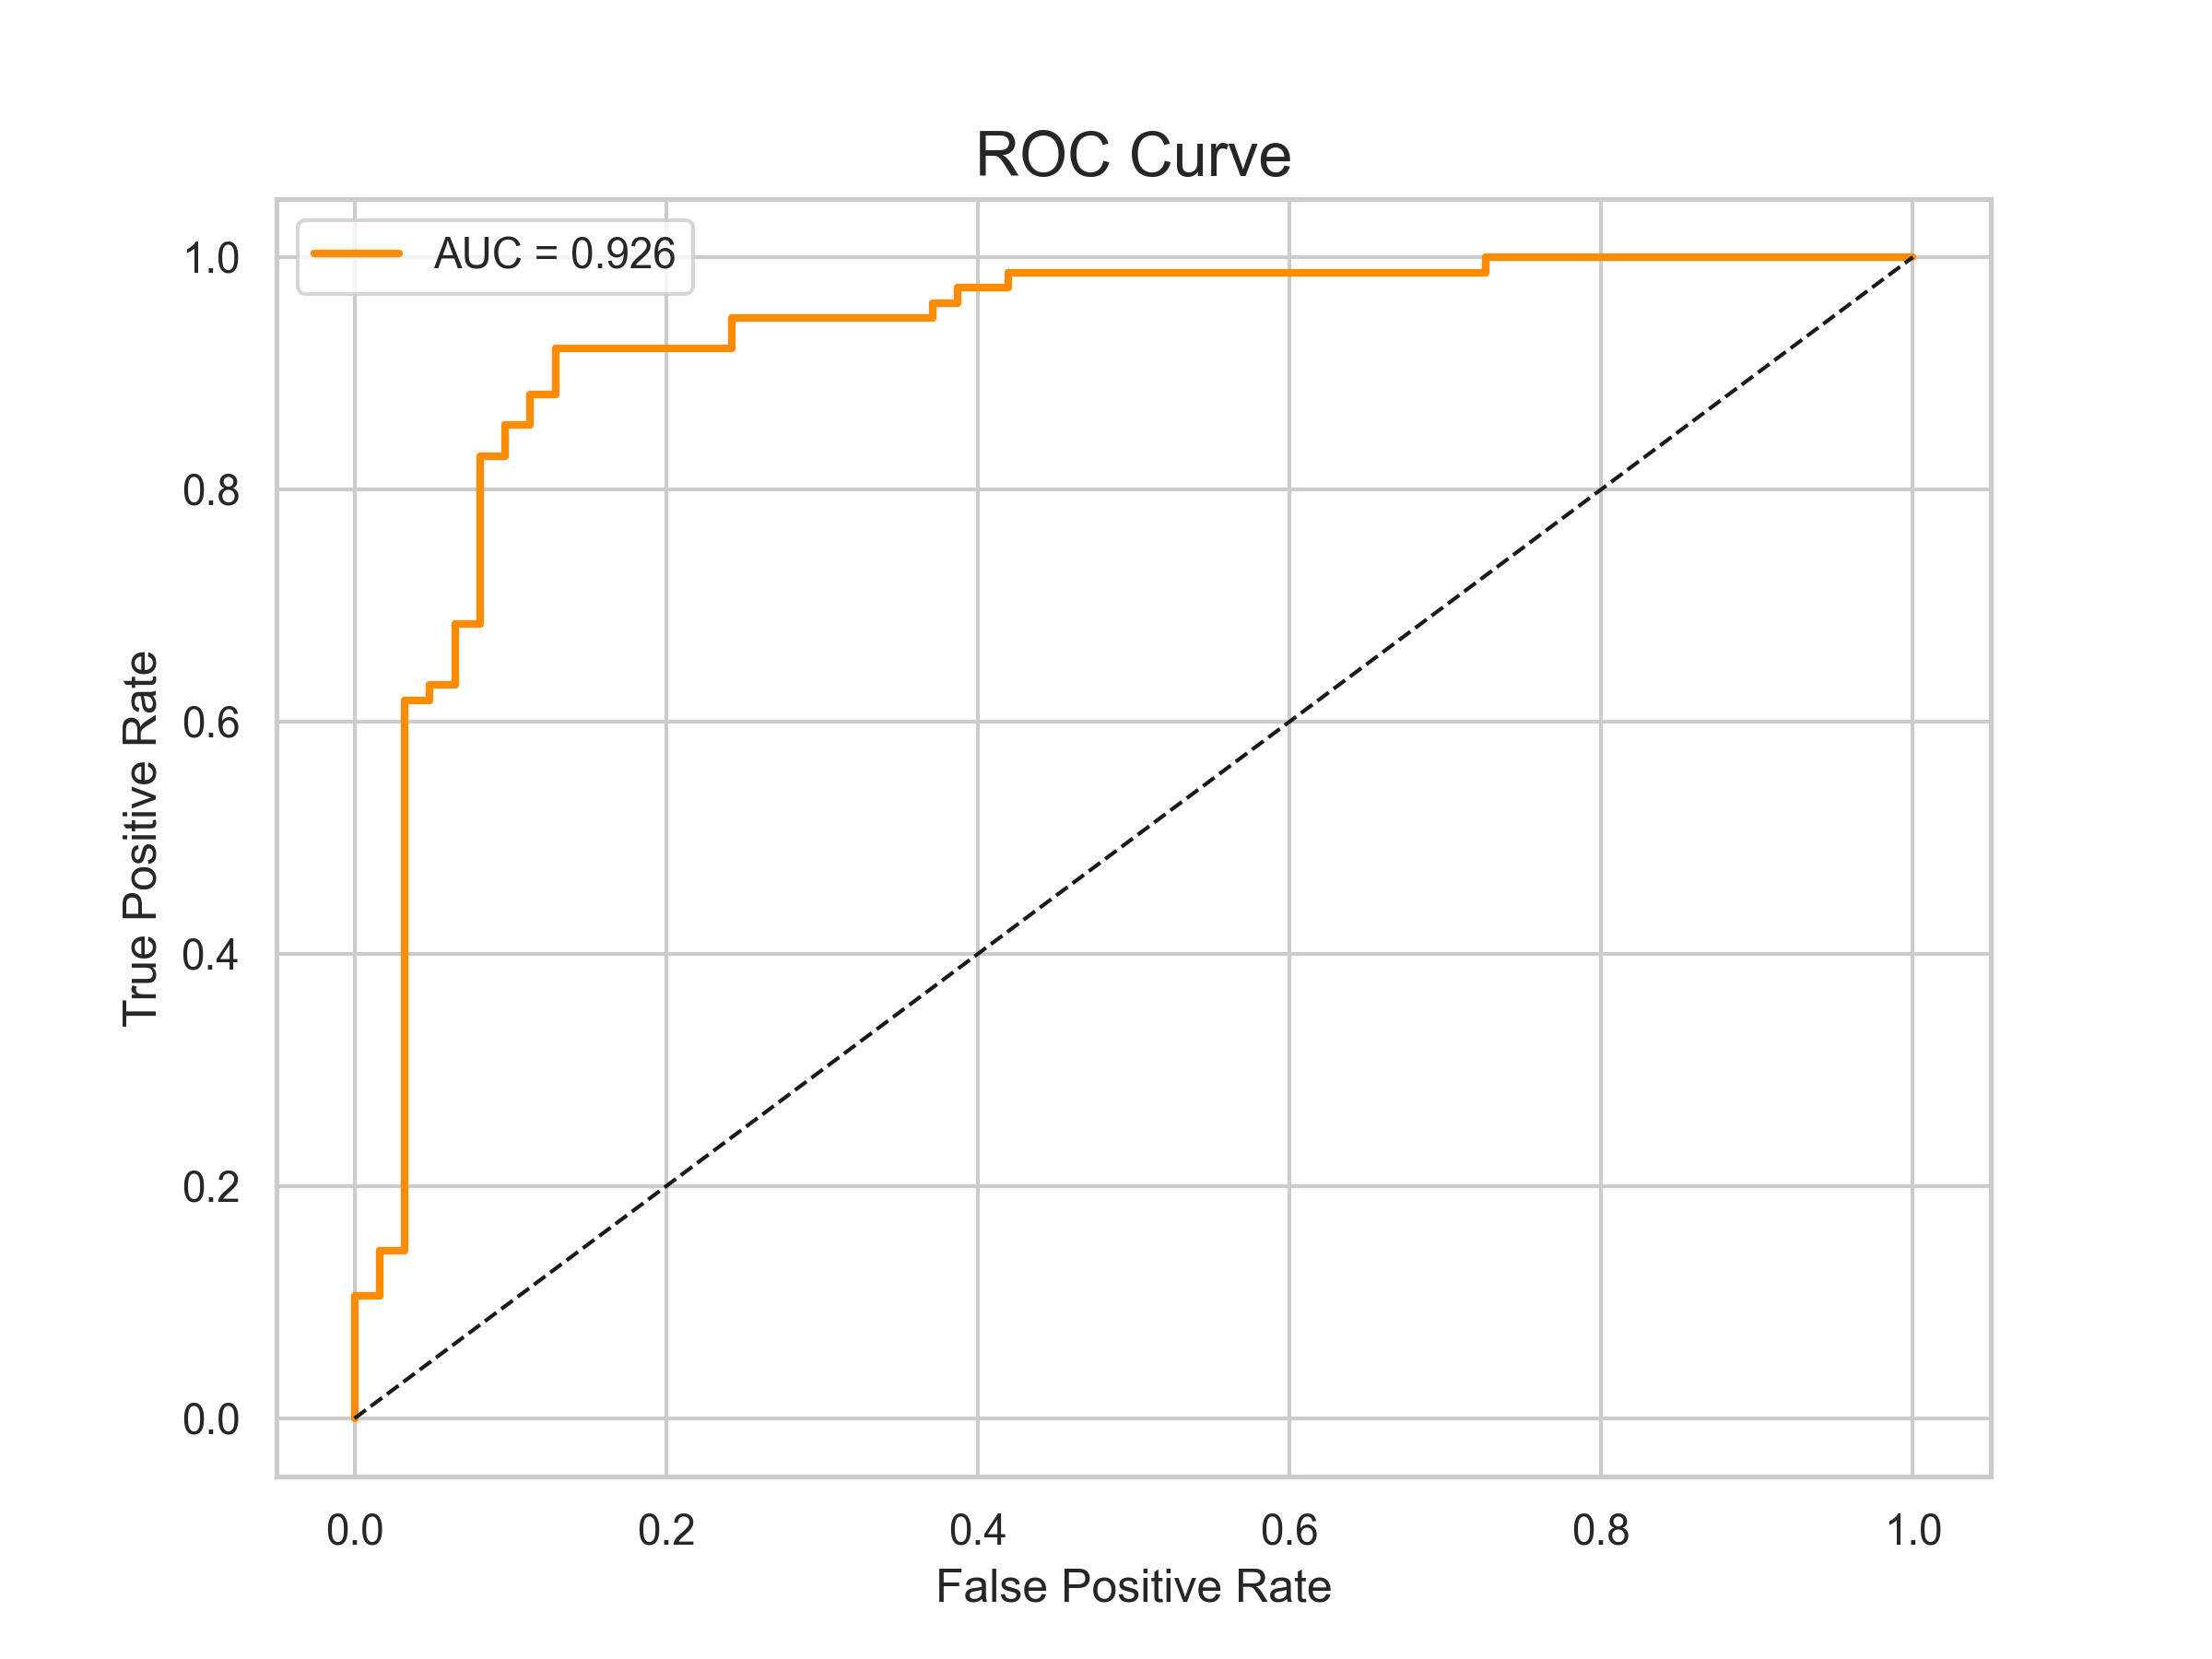

7. Challenges Faced
- OCR on Varied Reports: Noise, handwriting, and format variations caused extraction errors. Mitigated: Image preprocessing with OpenCV and layered regex.
- Model Accuracy: Initial overfitting on limited data. Resolved: Ensemble methods and hyperparameter tuning.
- Integration Issues: Flask-OCR-ML pipeline sync. Resolved: Modular code and extensive debugging.
- UI Responsiveness: Mobile compatibility. Resolved: Bootstrap implementation.

8. Learnings & Skills Acquired
- Advanced Python programming, Flask web development, Scikit-Learn ensembles.
- OCR implementation with Tesseract and regex.
- Full-stack integration, database design, data visualization.
- Domain knowledge in cardiovascular risks and CDSS.
- Soft skills: Project management, problem-solving, documentation

9. Testimonials from team
"Developing Cardio Vision AI was a transformative experience, blending AI with real healthcare impact. Achieving high accuracy and a user-friendly interface was highly rewarding." – Arjav Jain
"This project deepened my expertise in ML and web tech, teaching me the value of robust, ethical AI in medicine." – Arjav Jain

10. Conclusion
Cardio Vision AI successfully delivers an accurate, automated tool for heart disease risk detection, aligning with preventive healthcare goals. The internship enhanced my skills in AI-driven solutions and reinforced my career aspirations in health-tech.

11. Acknowledgements
Heartfelt thanks to Infosys Springboard for this enriching virtual internship, the platform mentors, and all supporters who made this journey possible.
.

